™

**CHAPTER –** **2**

**ON JOB TRAINING-1 “ Placement Management System”**

**ABSTRACT**

The **Placement Management System** is a web-based application designed to streamline and automate the entire placement process in educational institutions. This system enables students, placement officers, and companies to interact efficiently through a centralized platform, ensuring smooth coordination and effective management of placement-related activities.

The system allows **students** to register, update their profiles, upload resumes, and view company details, job postings, and interview schedules. **Placement officers** can manage student records, post job openings, track company visits, shortlist candidates, and generate reports. **Recruiters/companies** can access student profiles, post job requirements, and schedule interviews directly through the platform.

The system eliminates manual work, reduces paperwork, and enhances communication between students and recruiters. It ensures data accuracy, speeds up the recruitment process, and maintains transparency throughout. Developed using technologies such as HTML, CSS, JavaScript for the frontend, and PHP/MySQL for the backend, this system offers a user-friendly interface and secure access control for different users.

Overall, the Placement Management System serves as a powerful tool for educational institutions to manage campus placements efficiently and effectively.

**INTRODUCTION**

The Placement Management System is an essential tool designed to simplify and enhance the campus recruitment process in educational institutions. As the number of students and placement opportunities increases, managing placements manually becomes time-consuming, error-prone, and inefficient. This system provides a digital solution that automates various placement-related activities, making the process more streamlined and effective for students, placement officers, and recruiters.

Through this system, students can register their profiles, upload resumes, view job openings, and apply to companies based on their eligibility. Placement coordinators can manage student data, post job listings, communicate with companies, and generate reports. Recruiters, in turn, can access student profiles, shortlist candidates, and schedule interviews with ease.

The main goal of the Placement Management System is to ensure a smooth and transparent placement process while reducing the administrative workload. It improves coordination, enhances data accuracy, and enables faster decision-making. By digitizing placement operations, institutions can better serve their students and build stronger relationships with recruiting companies.

In today’s competitive educational environment, campus placements play a vital role in shaping students’ careers and establishing the reputation of institutions. Managing the entire placement process manually – from student registration to final offer letters – can be overwhelming and inefficient, especially in large institutions. To overcome these challenges, a **Placement Management System** provides a digital solution that automates and organizes all aspects of the placement process.

The system is designed to serve as a centralized platform for students, placement officers, and recruiters. It allows **students** to register themselves, update academic and personal details, upload resumes, and track job applications. **Placement officers** can manage company data, job postings, student eligibility criteria, interview schedules, and generate insightful reports for performance analysis. **Recruiters** gain access to eligible student profiles, schedule interviews, and communicate with placement cells easily.

**MOTIVATION**

**Challenges in Campus Recruitment**

* Inefficiency in candidate selection.
* Lack of centralized student information.
* Limited communication between recruiters and students.

**Motivation for the Project**

* To create an optimized platform that addresses these challenges.
* To enable a smooth and efficient recruitment experience for engineering students.

**Goals of the project:**

* Develop a user-friendly system to centralize student data.
* Implement modern sorting and filtering capabilities for recruiters.
* Streamline the recruitment workflow, saving time and improving selection quality.

**Benefits of the Platform:**

* For Students: Provides more accessible job opportunities.
* For Recruiters: Simplifies candidate shortlisting and assessment**.**

**LITERATURE SURVEY**

|  |  |  |  |  |
| --- | --- | --- | --- | --- |
| **SL No** | **Title** | **Author(s)** | **Year** | **Methods** |
| 1 | A Framework for Efficient Campus Recruitment System | Amit Sharma Priya Mehta | 2019 | Web based framework using MySQL for database management and PHP for server side scripting. |
| 2 | Online Student Recruitment and Placement System. | Rohan Gupta Meena Kapoor | 2020 | Uses Java and SQL-based backend to manage data and streamline recruitment notifications |
| 3 | Streamlining Campus Recruitment through Web Based Platform. | Lily Chen Jay Patel Saurabh Roy | 2018 | MVC architecture with JavaScript frontend and RESTful APIs for data management |
| 4 | Student Placement Management System using cloud computing. | Kunal Das Pooja Iyer | 2021 | Cloud-based system using Firebase for real-time data synchronization. |
| 5 | Automated Filtering and Ranking System for Job Recruitment. | Brian Williams Yichen Zhao | 2022 | Algorithmic filtering and machine learning for candidate ranking based on predefined criteria |
| 6 | Secure User Authentication for Web based Campus Recruitment. | Neha Patel Suresh Banerjee | 2023 | Implements multi-factor authentication and encryption techniques to enhance data security |

|  |  |  |  |  |
| --- | --- | --- | --- | --- |
| 7 | Intelligent Campus Placement System with Data Analytics. | Sneha Sharma Rajiv Bhatt | 2021 | Data analysis using Python and machine learning for predictive insights |
| 8 | Cloud Based Student Profile Management for Campus Recruitment. | Manish Patel Divya Sinha | 2022 | Implements Google Cloud for data storage and secure access across multiple devices |

Table 2.1 Literature Survery

**OBJECTIVES**

1. **User-Friendly Dashboards**

Interactive and intuitive dashboards provide clear insights for students, recruiters, and administrators, ensuring ease of navigation and efficient access to information

1. **Multiple Role – Based Secure Access**

Different user roles (students, recruiters, admin) are assigned specific access rights, ensuring data security and personalized functionality for each user.

1. **Sorting and Filtering Capabilities**

Advanced tools enable recruiters to efficiently search, sort, and filter candidates based on various criteria like skills, CGPA, and experience

1. **Scalable and Responsive Desing**

The platform is built to handle growing user data while offering a seamless experience across devices, from desktops to smartphones.

1. **Secure and User-Friendly Platform**

Ensures data security with robust authentication methods while maintaining a simple, intuitive interface for users.

1. **Improve Placement Rates and Career Opportunities**

Facilitates better recruiter-student interactions and enhances recruitment efficiency, leading to increased job placements and career growth for students

**PROBLEM FORMULATION**

**INTRODUCTION**

This **Placement Management System** is designed to streamline and optimize the campus recruitment process for engineering students and recruiters, making it more efficient, faster, and user-friendly. The system allows recruiters to easily log in and access a detailed, comprehensive view of student profiles, which include key data such as academic qualifications, skills, and other relevant information. Recruiters can then leverage advanced sorting and filtering functionalities to shortlist candidates based on specific criteria like CGPA, skill sets, and experience, saving time and effort in the hiring process.

The platform features a user-friendly dashboard that allows recruiters to manage their shortlisted candidates, track application progress, and view the status of their recruitment efforts. Students are kept in the loop with real-time notifications that inform them of the status of their applications, upcoming recruitment events, and any updates related to their profiles, ensuring they are always well-informed.

With secure login mechanisms, automated sorting and filtering options, and modern web technologies, the system ensures a seamless, transparent, and secure experience for both recruiters and students. The integration of these features is designed to improve placement rates by simplifying and expediting the recruitment process, while also providing students with enhanced career opportunities. Ultimately, this system aims to bridge the gap between students and potential employers, helping both parties achieve their goals efficiently.

**PRESENT SYSTEM**

**Manual and Time-Consuming :** Right now, most recruitment processes are manual. Data is kept in spreadsheets or emailed documents, making it slow and prone to errors.

**Limited Data Access for Recruiters :** Student information like CGPA, skills, and project details isn’t always up-to-date or easy for recruiters to access, causing delays and confusion.

**Basic Filtering Options :** Recruiters have to manually sort through resumes without advanced filters. Finding candidates based on specific criteria, like top CGPA or specific skills, is challenging and takes a lot of time.

**Poor Communication with Students :** Students usually don’t get updates right away about their application status or interview schedules. They have to rely on emails or announcements, which can be delayed or missed.

**Security Risks :** With data scattered in different files and limited access control, student data might not be secure, which can lead to privacy issues.

**High Administrative Load :** Placement staff have to manage everything by hand, from collecting resumes to scheduling interviews, making the whole process tiring and hard to scale for larger student batches.

**PROPOSED SYSTEM**

**All-in-One Digital Platform:** The Placement Management System will have everything in one place. Recruiters, students, and admins can access up-to-date information, making it easy for everyone to get what they need without delays.

**Quick Access to Student Profiles:** Recruiters can quickly view detailed profiles with all the necessary info—CGPA, skills, certifications, etc.—without needing to go through separate files or request extra information.

**Easy Sorting and Filtering:** The system will have filters so recruiters can sort students by CGPA, skills, and other factors right away. This makes finding top candidates fast and simple.

**Scalable and Mobile-Friendly:** The system will work on both computers and phones, so users can access it anywhere. It’s built to handle more students and recruiters as needed without slowing down.

**Reduces Workload for Placement Staff:** By automating tasks like sorting applications and sending notifications, the system will free up time for placement staff, letting them focus on more important tasks.

**Role-Based Secure Access :** The system uses secure logins and role-based access controls, meaning that each user (student, recruiter, principal, or admin) has access to only the parts of the system they need

**PROBLEM STATMENT**

The campus recruitment process for engineering students is often inefficient, with challenges such as manual candidate selection, lack of centralized student data, and limited communication between recruiters and students. This project aims to develop a **Placement Management System** that streamlines recruitment by allowing recruiters to easily sort and filter candidates, while providing students with real-time updates on their application status and recruitment events. By leveraging modern web technologies, this system will enhance the recruitment process, improve placement rates, and provide better career opportunities for students

**ADVANTAGES**

* Faster recruitment process with quick access to student data.
* Easy access to student profiles for recruiters.
* Secure data management with role-based access.
* Reduced workload for placement staff through automation of routine tasks.
* Increased transparency in the recruitment process for both student and recruiters.

**REQUIREMENTS**

**FUNCTIONAL REUIREMENT**

The functional requirements of the system define the capabilities and features that the Placement Management System should offer to users

* **Authentication**

Recruiters must be able to securely log in using credentials.

* **Access to Recruiter Dashboard**

Recruiters must have access to a dedicated dashboard after successful login.

* **Access to Student Profiles**

Recruiters should view detailed student profiles, including CGPA, skills, and other relevant data.

* **Sorting and Filtering**

Ability to add students to a shortlist and manage the list through a dedicated dashboard.

* **User Authentication**

Students must log in securely to access the system.

* **Profile Management**

Students can create, update, and manage their profiles, including academic and personal details.

* **Recruitment Notification**

Students receive automated updates about their application status, interview schedules, and events.

**NON-FUNCTIONAL REQUIREMENT**

Non-functional requirements specify the quality attributes of the system, focusing on how the system peforms its functions. These requirements are crucial for ensuring that the system not only meets functional expectations but also provides a satisfactory user experience. Below are the key non-functional requirements for Placement management system

**Performance Requirements**

The system should respond to user actions (e.g., login, filtering) quickly, with minimal latency.

The platform should be able to handle multiple simultaneous users without performance degradation.

**Usability**

The interface should be intuitive and user-friendly, ensuring ease of navigation for both recruiters and students.

The system should offer clear instructions and tooltips to assist users in using features effectively.

**Backup and Recovery**

Regular backups of student and recruiter data must be performed to prevent data loss.

A robust recovery process should be in place to restore the system to its previous state in case of data corruption or system failure.

**Security**

The system should have strong encryption for sensitive data, such as student profiles and recruiter information

User authentication should be secure, incorporating multi-factor authentication (MFA) for sensitive actions.

**Scalability**

The system should be able to scale to accommodate an increasing number of users and data without affecting performance

The platform should allow for easy addition of new features as required by evolving needs.

**Reliability**

The system should be available 24/7 with minimal downtime.

Monitoring tools should be used to detect and address potential issues proactively.

**HARDWARE & SOFTWARE REQUIREMENTS**

**Hardware Requirements:**

* Processor : Dual-core processor or higher.
* RAM : Minimum 4 GB.
* Storage : free disk space.
* Display : 1024x768 resolution or higher.
* Network : Stable internet connection

**Software Requirements:**

**Operating System:**

* Windows , macOS, or Linux etc.
  + **Browser:** 
    - -Google Chrome (latest version), Mozilla Firefox, Microsoft Edge, or Safari.
  + **Additional:**
    - -PDF Reader (for viewing reports).
  + **Development Tools:** 
    - * Code Editor: VS Code, Sublime Text, or Atom.
      * Browser: Google Chrome, Firefox (for testing)
  + **Backend Technology:**
    - -PHP for server-side scripting.
    - -MySQL or MongoDB for the database
  + **Frontend Technology:**
    - -HTML, CSS, and JavaScript for user interfaces.
    - -Frameworks like Bootstrap for responsiveness.
  + **Web Server:**
    - -Apache (e.g., XAMPP or WAMP for local testing),Node Server.
  + **Additional Libraries/Tools:**

-Version Control: Git/GitHub for source code management.

**DESIGN**

**ARCHITECTURE DIAGRAM**

An architecture diagram for a Placement Management System typically visualizes the components, relationships, and data flow within the system. It provides an overview of how different parts of the system interact with each other and helps in understanding the overall design of the application.

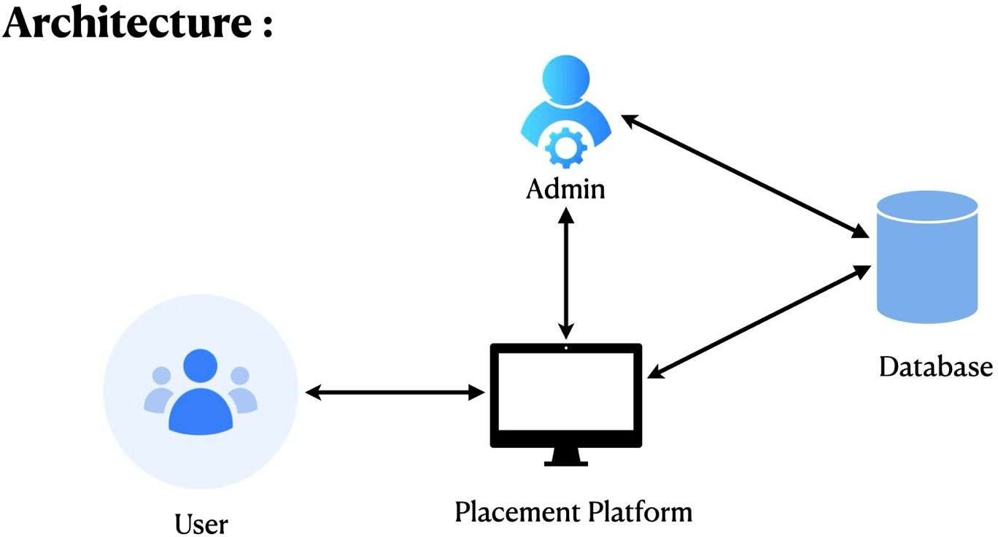

Figure 2.1 Software Architecture

**USE CASE DIAGRAM**

A use case diagram will show how users interact

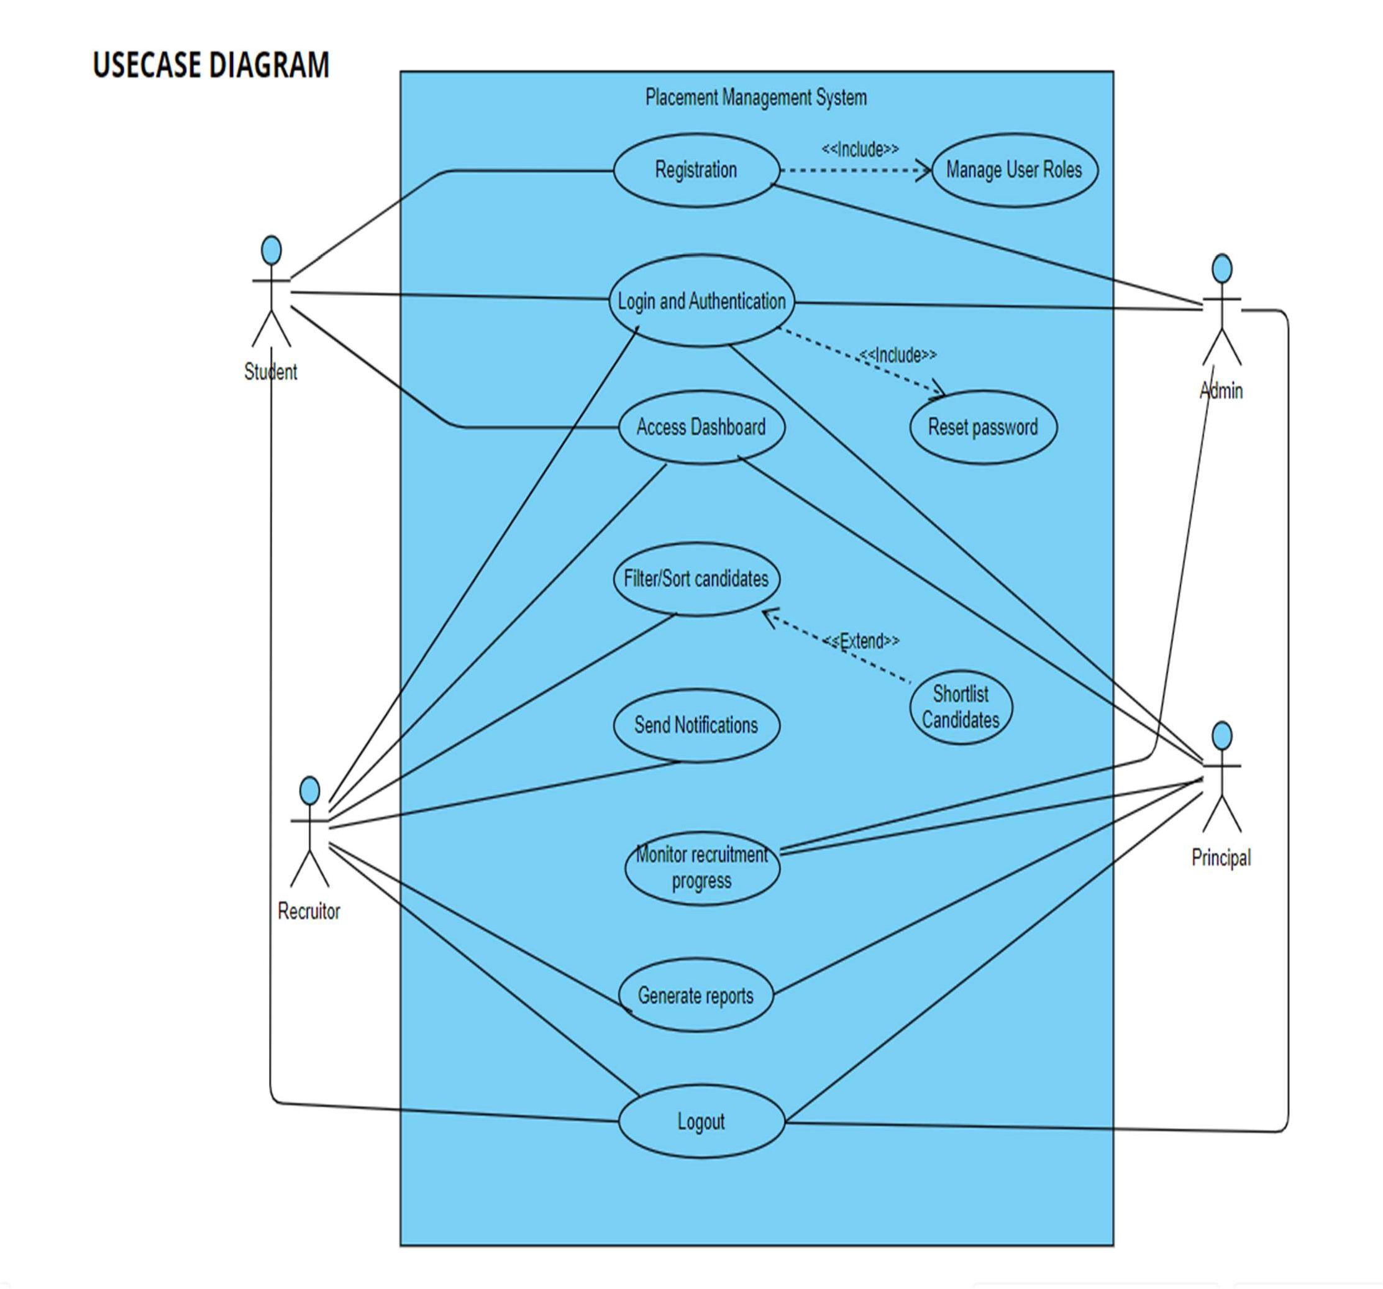

Figure 2.2 Use Case Diagram

**SEQUENCE DIAGRAM**

The sequence diagram will depict the flow of actions in the system:

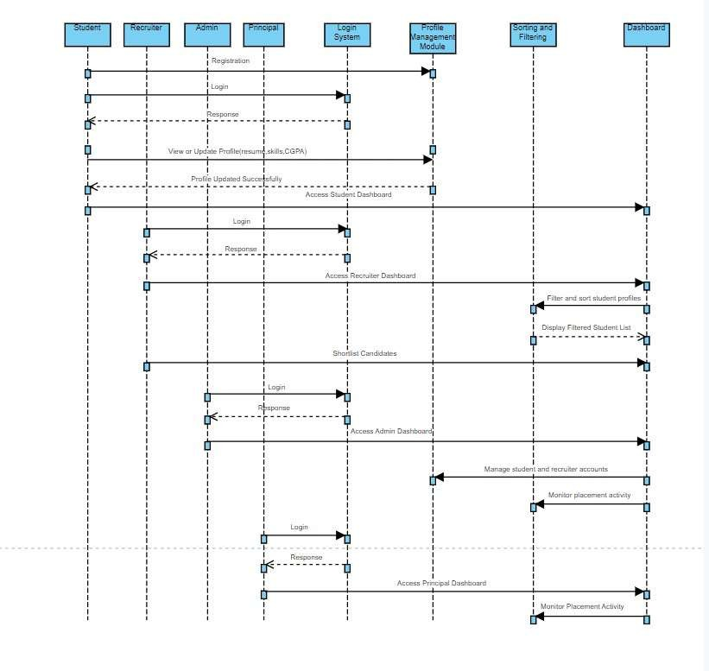

Figure 2.3 Sequence Diagram

**DFD DIAGRAM**

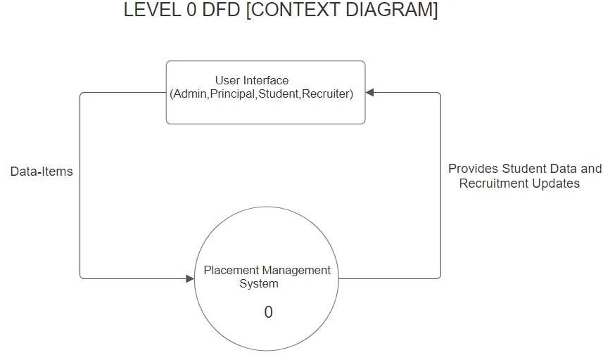

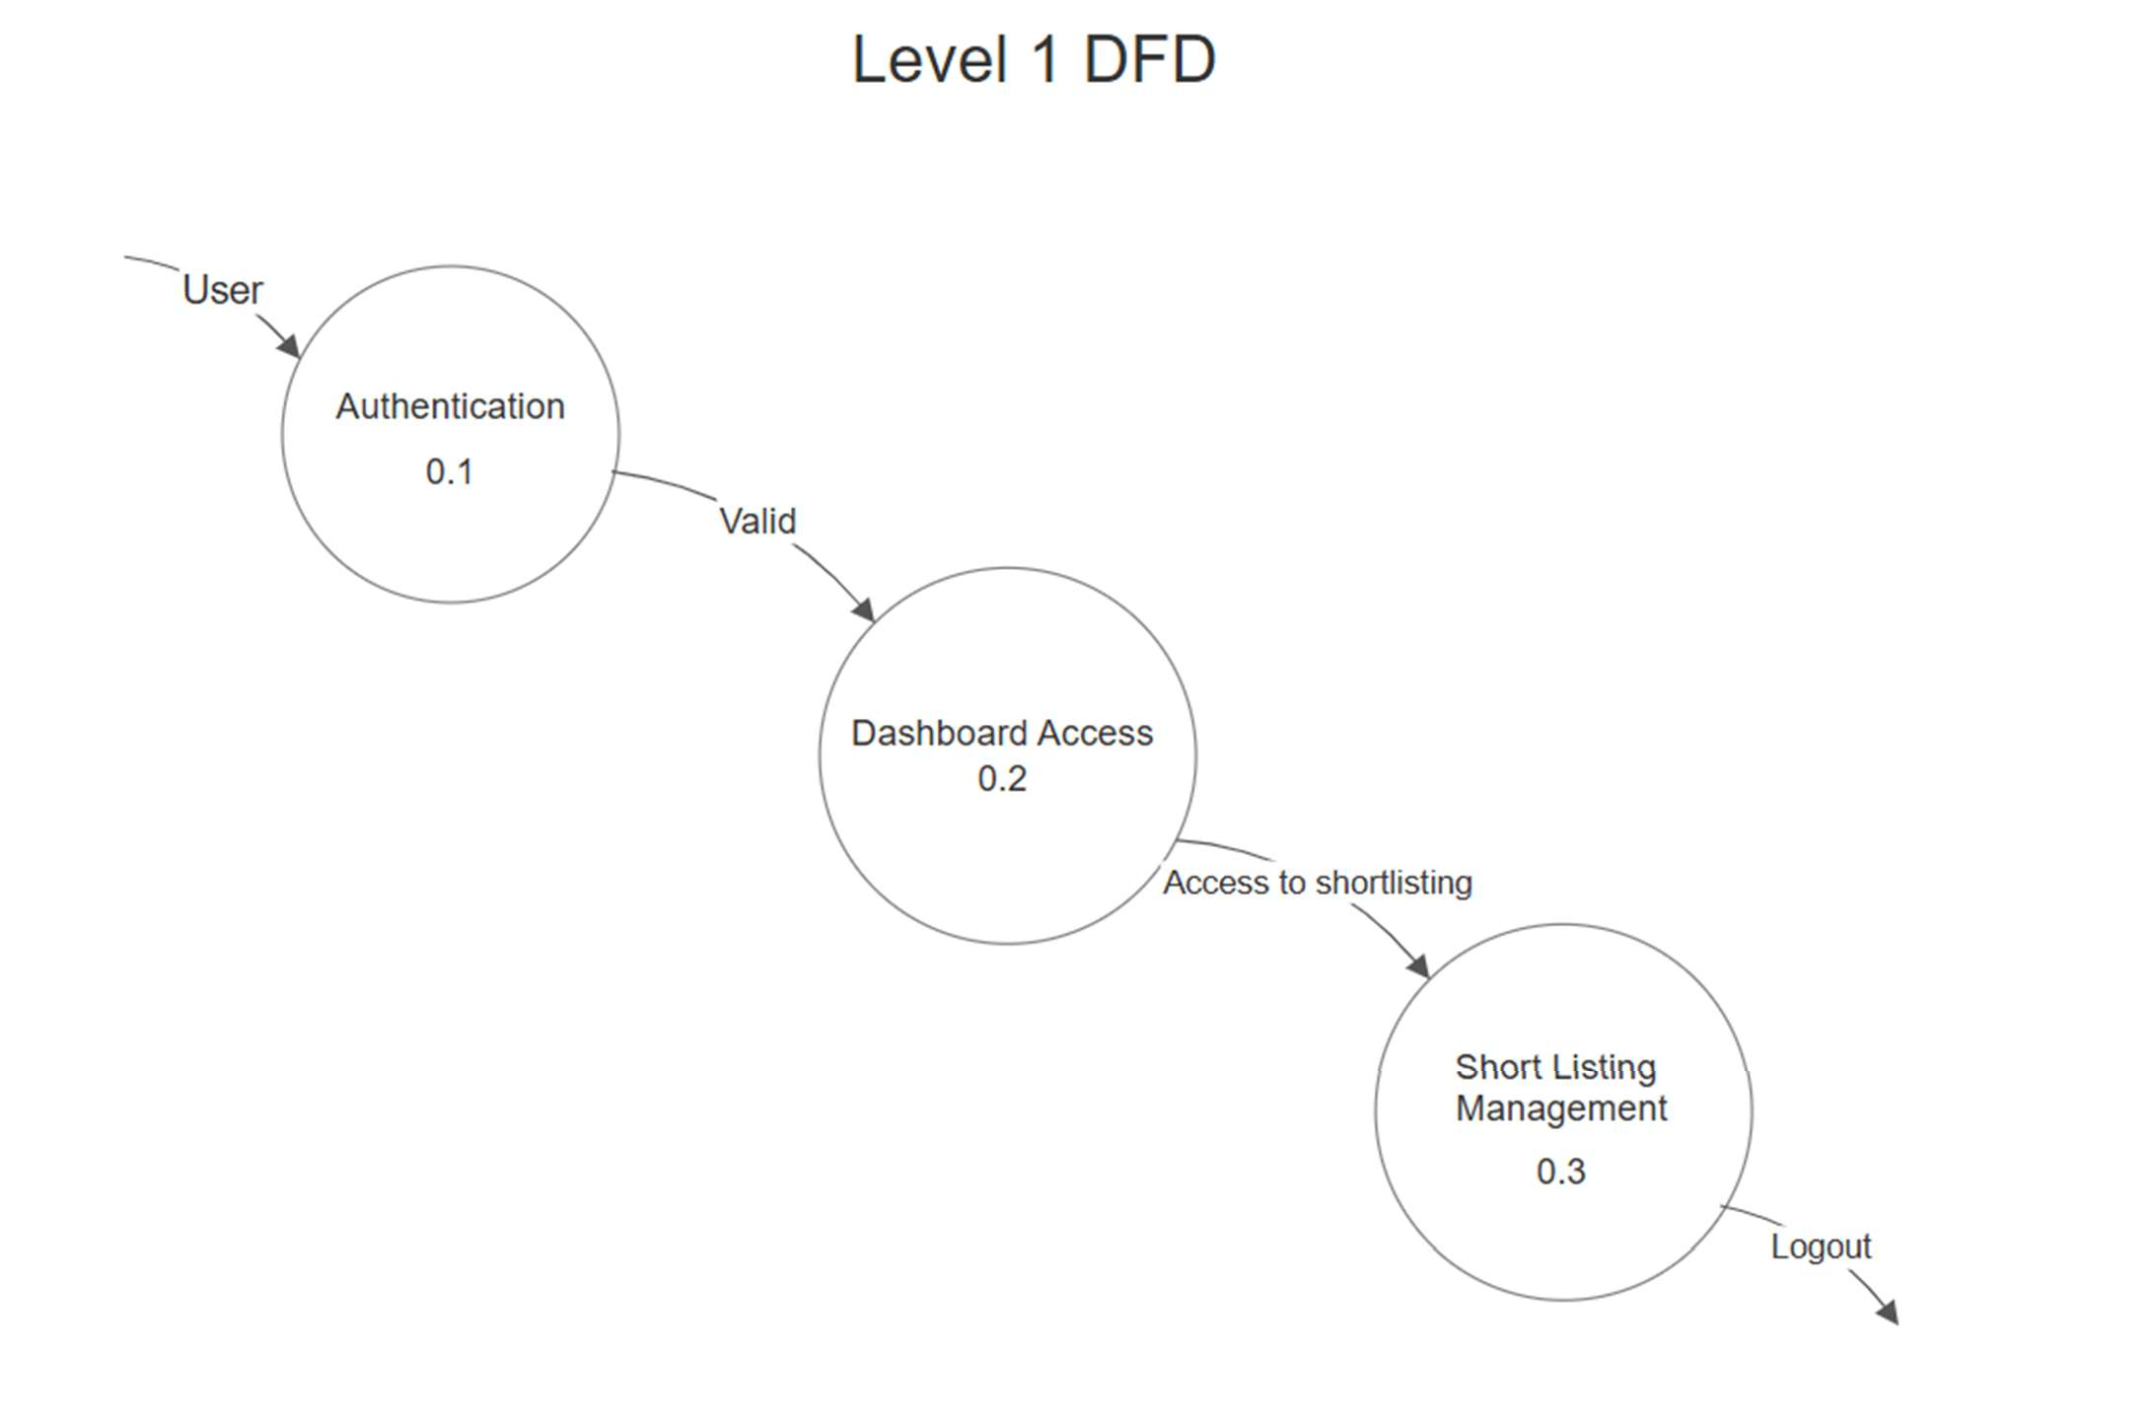

Figure 2.4 DFD Diagram

**IMPLEMENTATION**

**FLOW OF PROJECT**

**1. User opens the homepage.**

The system displays login options for students, recruiters, and admin.

**2. User logs in.**

Based on the role, the user is redirected to their respective dashboard (Student/Recruiter/Admin).

**3. Student Dashboard**

**View Job Listings:** Students browse available job postings.

**Apply for a Job:** Students select a job and submit their application.

**View Notifications:** Students check updates on application status or upcoming events.

**Update Profile:** Students manage their personal, academic, and skill details

**4. Recruiter Dashboard:**

**Search Candidates:** Recruiters use sorting and filtering features to shortlist students based on CGPA, skills, or other criteria.

**View Profiles:** Recruiters access detailed profiles of shortlisted candidates.

**Manage Shortlist:** Recruiters save or remove candidates from their shortlist.

**Post Jobs:** Recruiters create new job listings for students to apply to.

**5. Admin Dashboard:**

**Manage Users:** Admins add, remove, or update user accounts for students and recruiters.

**Monitor Activity:** Admins track user activity and system logs.

**Generate Reports:** Admins generate reports on placement statistics and system performance.

**6. Real-Time Notifications:**

The system sends notifications to users for events like new job postings, application status updates, and recruitment schedules.

**7. System Backup and Recovery:**

Regular backups are performed to ensure data safety, and the system recovers data in case of failure.

**8. Logout:**

Users can log out securely and return to the homepage.

**IMPLIMENTATION OF PROJECT**

**1. Front-End Development**

**HTML (Hypertext Markup Language):**

Structure web pages using semantic HTML elements like , , , , and .

Design forms for user login, registration, and profile updates using Top of Formand elements.

Create tables and grids for displaying job postings, student profiles, and shortlisted candidates.

**CSS (Cascading Style Sheets):**

Style the layout, colors, fonts, and overall design to ensure a professional appearance.

Implement Bootstrap classes for responsive grids, typography, buttons, and navigation bars to save development time.

Use media queries to enhance responsiveness and optimize the layout for various screen sizes (desktop, tablet, mobile).

Customize Bootstrap components for branding and a consistent design theme.

**JavaScript (JS):**

**Enhance interactivity, such as:**

Validating user inputs on forms (e.g., login and registration).

Dynamically updating job lists and student profiles without reloading the page using AJAX requests.

Implementing modals (pop-ups) for viewing detailed student or job information.

Use simple JavaScript for client-side functionality like toggle menus, tabs, or alert messages.

Optionally integrate third-party libraries (e.g., jQuery) for easier DOM manipulation.

**PHP Integration (Front-End):**

Use PHP to dynamically generate HTML content (e.g., job listings, student profiles, recruiter details) based on database queries.

Handle form submissions securely and process data in conjunction with backend logic.

Ensure smooth navigation between pages using PHP routing and session management. **Bootstrap:**

**Use Bootstrap for:**

Pre-designed components like navbars, modals, dropdowns, carousels, and form elements.

Grid layout system for structuring dashboards and profile pages.

Alerts for displaying success/error messages (e.g., "Login Successful," "Application Submitted").

Customize the Bootstrap theme using CSS for a unique look and feel.

**Responsive and User-Friendly Design:**

Ensure the platform is easy to navigate for students, recruiters, and admins.

Optimize pages to load quickly, with a focus on mobile-first design principles.

**Advanced Features:**

Use Bootstrap's JavaScript plugins for interactive elements like tooltips, dropdowns, and collapsible menus.

Optionally integrate interactive charts or graphs for displaying placement statistics using libraries like Chart.js.

**2. Back-End Development**

**Server-Side Scripting with PHP**

Use PHP to handle business logic, process user requests, and interact with the database.

Implement secure user authentication and role-based access (Student, Recruiter, Admin).

Process form submissions for actions like login, registration, profile updates, job applications, and job postings.

**Database Integration**

Use MySQL or similar relational databases to store and manage data.

Use PHP Data Objects (PDO) or MySQLi to execute database queries securely.

**Example:** Use prepared statements to prevent SQL injection attacks.

**Design database tables for:**

* Students (e.g., id, name, CGPA, skills)
* Recruiters (e.g., id, company_name, job_postings)
* Applications (e.g., id, student_id, job_id, status)
* CREATE TABLE plcm
* id INT AUTO_INCREMENT PRIMARY KEY
* Subject VARCHAR(255) NOT NULL,
* Message TEXT NOT NULL,
* Images VARCHAR(255) DEFAULT NULL,
* Created at (TIMESTAMP DEFAULT CURRENT_TIMESTAMP);

**Conclusion**

This implementation plan outlines the technical aspects of building the placement management system. By combining HTML, CSS, and JavaScript on the front-end with PHP on the back-end and MySQL for database management.

**PSEUDO CODE**

**1. User Authentication Based on Role**

FUNCTION authenticateUser(email, password, role):

user = FETCH user FROM database WHERE email = email AND role = role IF user EXISTS:

IF password_verify(password, user.password_hash): START session

SET session variables (user_id, role) RETURN "Login Successful", role

ELSE:

RETURN "Invalid Password" ELSE:

RETURN "User Not Found" END FUNCTION

**2.Dashboard Access Based on Role**

FUNCTION getDashboard(role): SWITCH role:

CASE "Student":

RETURN studentDashboard() CASE "Recruiter":

RETURN recruiterDashboard() CASE "Placement Officer":

RETURN placementOfficerDashboard() CASE "Admin":

RETURN adminDashboard() DEFAULT:

RETURN "Invalid Role" END FUNCTION

**1.Student Role**

**Apply for Placement Drive**

FUNCTION applyForPlacementDrive(student_id, drive_id):

student = FETCH student FROM database WHERE id = student_id drive = FETCH drive FROM database WHERE id = drive_id

IF student.CGPA >= drive.minimum_CGPA:

INSERT INTO applications (student_id, drive_id, status)

VALUES (student_id, drive_id, "Applied")

RETURN "Application Successful" ELSE:

RETURN "You do not meet the eligibility criteria" END FUNCTION

**2. Recruiter Role**

**Post a job**

FUNCTION postJob(recruiter_id, job_title, job_description, eligibility_criteria): jobData = {

"recruiter_id": recruiter_id, "job_title": job_title, "job_description": job_description,

"eligibility_criteria": eligibility_criteria

}

INSERT INTO jobs (jobData) RETURN "Job Posted Successfully"

END FUNCTION

**3. Placement Officer Role**

**Generate Placement Report**

FUNCTION generatePlacementReports():

placements = FETCH ALL placements FROM database statistics = {

"total_students_placed": COUNT(placements WHERE status = "Placed"),

"total_drives_conducted": COUNT(placement_drives), "highest_CGPA": MAX(student.CGPA WHERE status = "Placed"), "average_CGPA": AVG(student.CGPA WHERE status = "Placed")

}

RETURN statistics END FUNCTION

**4. Admin Role**

**Manage User Accounts**

FUNCTION manageUserAccounts(action, user_id, user_data = NULL): SWITCH action:

CASE "Add":

INSERT INTO users (user_data) RETURN "User Added Successfully"

CASE "Update":

UPDATE users SET user_data WHERE id = user_id RETURN "User Updated Successfully"

CASE "Delete":

DELETE FROM users WHERE id = user_id RETURN "User Deleted Successfully"

DEFAULT:

RETURN "Invalid Action" END FUNCTION

**TESTING**

**DIFFERENT STEPS OF TESTING**

The system will be subjected to the following levels of testing:

1. **Unit Testing**

* Each individual module will be tested independently to ensure correctness.

**Examples:**

* Student login functionality.
* Placement officer dashboard.
* Recruiter dashboard.
* Notifications system

1. **Integration Testing**

* Ensures that all modules work seamlessly together.

**Examples:**

* Verify that student preferences are reflected in placement drive eligibility.
* Ensure recruiter job postings are visible to eligible students.
* Test interaction between the placement officer’s dashboard and system-wide reports.

1. **System Testing**

* The complete system will be tested to identify bugs and ensure smooth operation. **Examples:**
* Simulate multiple users (students, recruiters, placement officers, admins) accessing the system simultaneously.
* Test end-to-end workflows, such as the recruiter shortlisting candidates.

1. **User Acceptance Testing (UAT)**

* Final product will be tested by real users (students, recruiters, placement officers, and admins) to ensure it meets expectations and usability standards.

**Examples:**

* Gather feedback from students on the dashboard usability and navigation.
* Confirm that recruiters can easily filter and shortlist candidates.
* Verify that placement officers can efficiently access system.
* Test admin functionalities like managing user accounts and permissions.

**TEST CASES**

**Student Module**

| Test Case ID | Description | Input | Expected Result |
| --- | --- | --- | --- |
| TC001 | Student Registration | Valid name, email, password | Account created successfully |
| TC002 | Invalid Email during Registration | Invalid email format | Error message: "Enter valid email" |
| TC003 | Login with Correct Credentials | Valid email and password | Dashboard is displayed |
| TC004 | Login with Incorrect Password | Valid email, wrong password | Error message: "Incorrect password" |
| TC005 | Update Profile | New phone number/address | Profile updated successfully |
| TC006 | Upload Resume | .PDF or .DOCX file | Resume uploaded successfully |

Table 2.2 Student Modul Test Case

**Placement Officer/Admin Module**

| Test Case ID | Description | Input | Expected Result |
| --- | --- | --- | --- |
| TC009 | Add Company Details | Company name, role, package | Company added to database |
| TC010 | Post Job Opening | Job role, eligibility, date | Job visible to eligible students |
| TC011 | View Applied Students | Click on job post | List of applicants displayed |
| TC012 | Generate Placement Report | Select year/department | Report generated in PDF/Excel |
| TC013 | Send Notification | Message + student list | Notification sent successfully |

Table 2.3 Admin Modul Test Case

**Recruiter Module**

| Test Case ID | Description | Input | Expected Result |
| --- | --- | --- | --- |
| TC014 | Recruiter Registration | Company name, email, password | Recruiter account created |
| TC015 | Login as Recruiter | Valid credentials | Recruiter dashboard is displayed |
| TC016 | View Student Profiles | Click on job applied list | Eligible students' profiles are shown |
| TC017 | Schedule Interview | Select date/time + students | Interview schedule saved and notified |

Table 2.4 Recruiter Modul Test Case

**Security & Validation**

| Test Case ID | Description | Input | Expected Result |
| --- | --- | --- | --- |
| TC018 | Access without Login | Try accessing dashboard URL | Redirected to login page |
| TC019 | SQL Injection Test | ' OR 1=1-- in login form | Input sanitized, no login |
| TC020 | File Upload Validation | Upload .exe file as resume | Error: "Invalid file format" |

Table 2.5 Security & Validation Test Case

**RESULTS**

**SNAPSHOT**

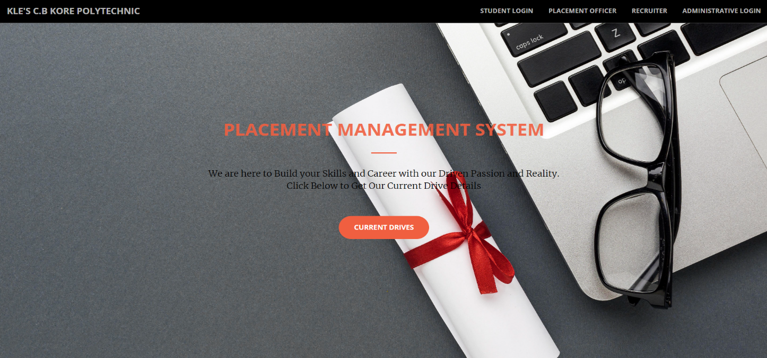**Home Page:**

Figure 2.5 Home Page

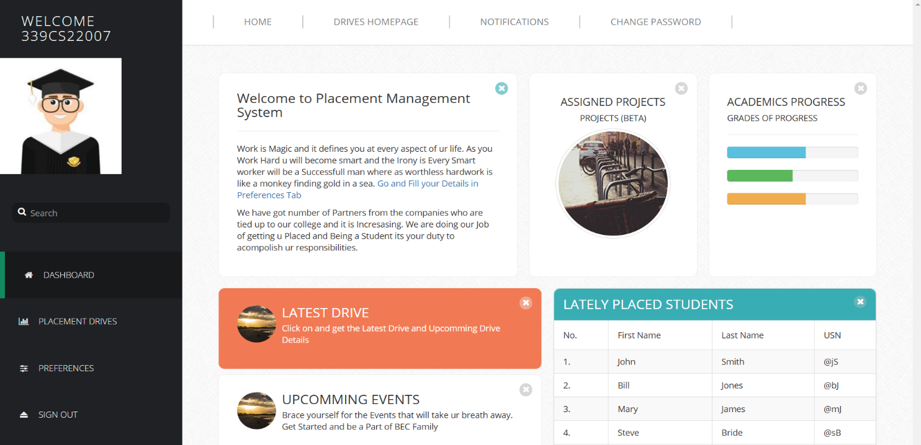**Student Dashboard**

Figure 2.6 Student Dashboard

**Placement officer Dashboard**

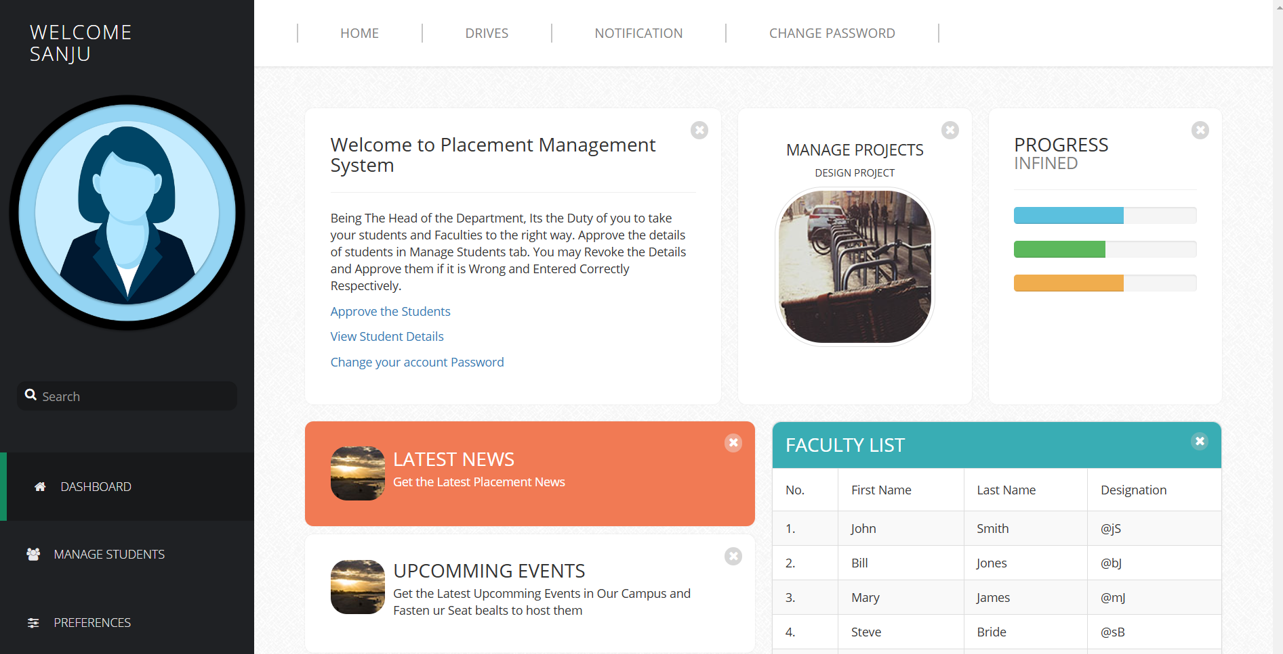

Figure 2.7 Placement Officer Dashboard

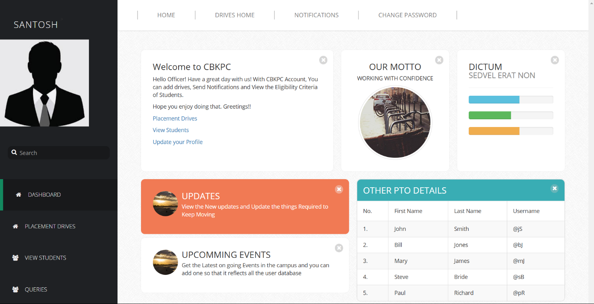**HOD Dashboard**

Figure 2.8 HOD Dashboard

**Principal Dashboard**

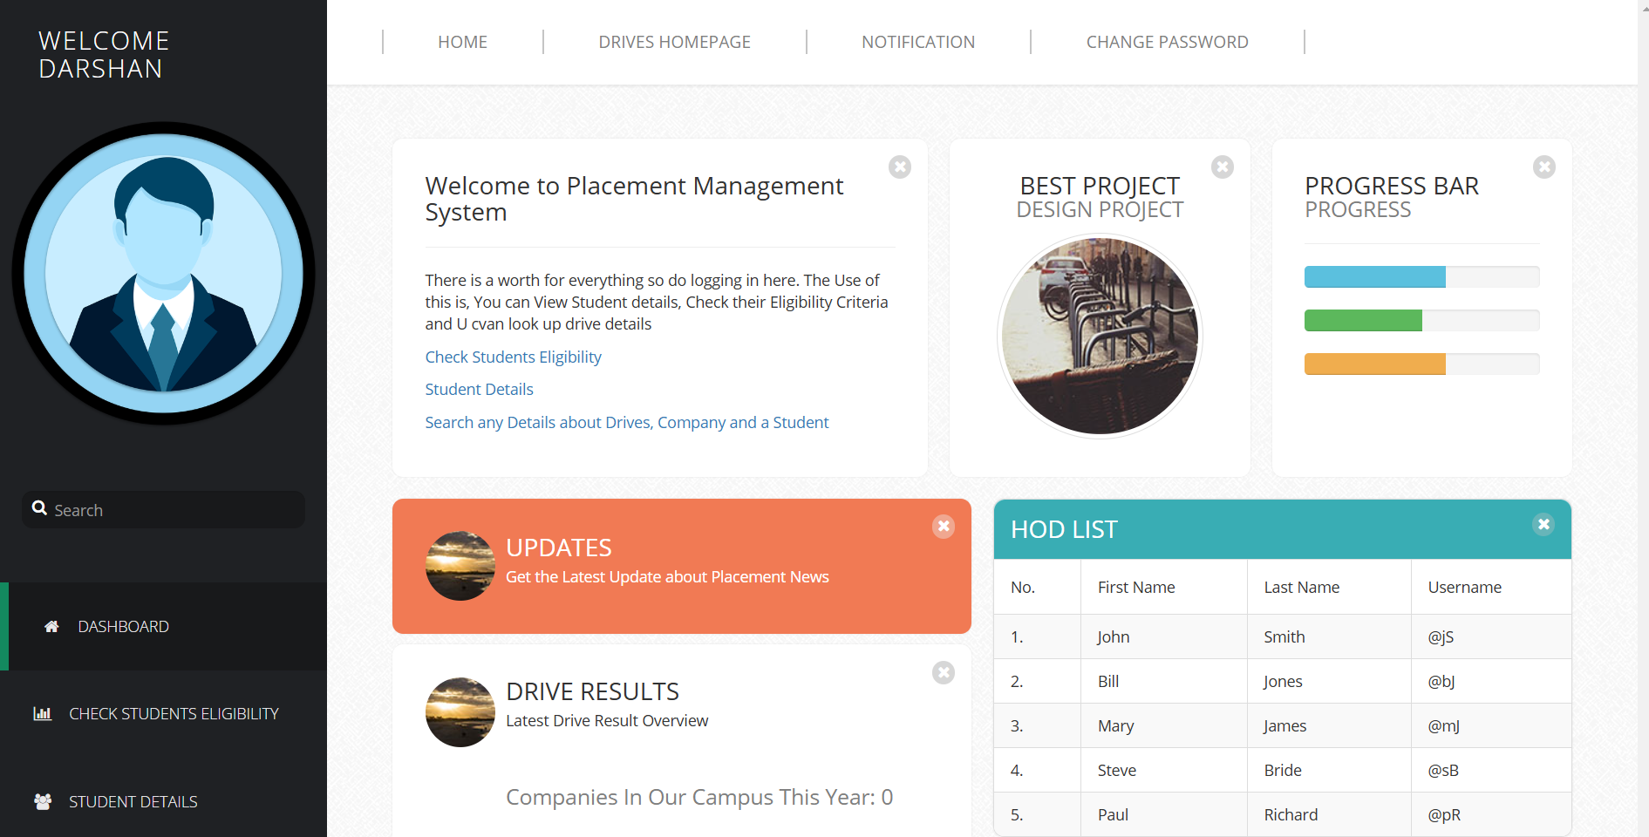

Figure 2.9 Principal Dashboard

**SCOP FOR FUTURE WORK**

The Placement Management System has established a solid foundation for efficient campus recruitment, yet there are several areas where the system can be expanded and improved upon. Below are potential directions for future development:

**AI-Powered Job Matching:**

Scope: Implement machine learning algorithms to improve job and candidate matching. By analyzing student profiles (skills, interests, GPA, past experiences) and recruiter requirements (skills, experience level), the system can provide more accurate job recommendations for students and suggest the best candidates for recruiters.

Benefit: This would streamline the recruitment process, saving time for both students and recruiters by presenting the most relevant opportunities.

**Interview Scheduling Integration:**

Scope: Incorporate an interview scheduling feature where recruiters can directly book interview slots with candidates based on their availability. This could be integrated with popular calendar tools (Google Calendar, Outlook) to manage schedules efficiently.

Benefit: This would enhance the user experience by reducing coordination overhead and ensuring smoother scheduling.

**Real-Time Analytics for Recruiters:**

Scope: Provide recruiters with real-time dashboards that showcase metrics like the number of applications received, the most popular job postings, and the progress of each candidate in the recruitment pipeline.

Benefit: Recruiters can make data-driven decisions to adjust job requirements or outreach strategies based on candidate behavior and application trends.

**Student Skill Development Integration:**

Scope: Create a feature that recommends courses, certifications, or workshops based on the skills in demand for job postings within the system. Collaborating with e-learning platforms or industry leaders can provide valuable resources.

Benefit: This would enable students to proactively improve their employability, enhancing the overall value of the system.

**Mobile Application:**

Scope: Develop a mobile application to make the platform accessible from smartphones, allowing students and recruiters to stay updated on the go, view job opportunities, apply, or review applications anytime and anywhere.

Benefit: A mobile app would increase user engagement and convenience, aligning with the growing trend of mobile-first solutions.

**Integration with Job Portals and Social Networks:**

Scope: Integrate the system with popular job portals (like LinkedIn, Indeed) and social networks to allow students to import their profiles, making the application process smoother and faster. Recruiters can also post job openings on multiple platforms at once.

Benefit: This would increase the reach of job opportunities and make the system more accessible for both students and recruiters.

**Internship Opportunities and Campus Events:**

Scope: Extend the system to include internship opportunities, campus recruitment drives, and other career development events, allowing students to explore internships alongside full-time job options.

Benefit: This provides students with a more holistic view of their career options while giving recruiters access to a broader talent pool.

**Real-Time Feedback System:**

Scope: Implement a feedback system where students can receive feedback from recruiters on their applications and interviews. This would allow students to understand areas of improvement and refine their future applications.

Benefit: It encourages continuous learning and improvement, enhancing the overall recruitment process.

**CONCLUTION**

This project successfully demonstrates the creation of a comprehensive and interactive placement management system aimed at optimizing campus recruitment. The system enhances the recruitment process by providing essential features such as student profile management, job posting and application tracking, and seamless interaction between students, recruiters, and administrators. The primary goal of streamlining campus recruitment and improving job placement rates has been achieved through an intuitive and user-friendly interface that simplifies the process for all stakeholders involved.

By offering a centralized platform, the system effectively caters to the needs of students and recruiters, making it easier for students to apply to relevant job opportunities and for recruiters to find qualified candidates based on key criteria like skills and CGPA. Additionally, the automated notification system ensures timely updates, keeping students and recruiters informed throughout the recruitment cycle.

The inclusion of data analytics and sorting/filtering capabilities for both students and recruiters further enhances decision-making and streamlines candidate selection. The role-based access control ensures secure and appropriate usage, with administrators maintaining oversight over all activities. Looking ahead, there are several opportunities to enhance the system further. Potential improvements include:

Real-Time Analytics: Introducing real-time insights and reports for recruiters and administrators, allowing for more effective decision-making and recruitment planning. In conclusion, this project not only provides an efficient and effective placement management system but also lays the foundation for future developments in recruitment technology. By focusing on user engagement, data-driven decision-making, and continuous improvement, the system has the potential to evolve with the changing landscape of campus recruitment, ultimately benefiting both students and recruiters

**REFERENCE**

**Books:**

1. T. Felke-Morris, Web Development and Design Foundations with HTML5, 9th ed. Boston, MA, USA: Pearson, 2018.
2. . L. Welling and L. Thomson, PHP and MySQL Web Development, 5th ed. Boston, MA, USA: Addison-Wesley, 2016.
3. . D. R. Brown, The Restaurant Manager's Handbook: How to Set Up, Operate, and Manage a Financially Successful Food Service Operation, 4th ed. Ocala, FL, USA: Atlantic Publishing Company, 2011.
4. . C. A. Rinzler, Nutrition for Dummies, 7th ed. Hoboken, NJ, USA: John Wiley & Sons, 2016.

**Websites/Online Articles:**

1. W3Schools, “HTML tutorial,” W3Schools.com, https://www.w3schools.com/html (accessed Sep. 24, 2024).
2. Mozilla Developer Network (MDN), “HTML: HyperText Markup Language,” Mozilla.org, https://developer.mozilla.org/en-US/docs/Web/HTML (accessed Sep. 24, 2024).
3. M. Pattison, “Macronutrients: Definition, importance, and food sources,” Healthline, Aug. 19, 2019. [Online]. Available: https://www.healthline.com/nutrition/what-are-macronutrients (accessed Sep. 24, 2024).
4. S. Marshall, “A guide to the basic nutritional breakdown of meals,” The Spruce Eats, Aug. 15, 2023. [Online]. Available: https://www.thespruceeats.com (accessed Sep. 24, 2024).
5. Stack Overflow, “How to implement a database-driven web application in PHP,” Stackoverflow.com. [Online]. Available: https://stackoverflow.com/questions/48446592/how-to-implement-php (accessed Sep. 24, 2024).

**Research Papers:**

1. J. M. Smith and R. Jones, “The impact of web-based menu management systems on restaurant business,” Int. J. Hosp. Manag., vol. 65, pp. 45-52, Oct. 2017.
2. L. A. White and T. Green, “Interactive food labeling and nutritional information systems,” J. Nutr. Educ. Behav., vol. 50, no. 3, pp. 125-132, Jun. 2018.